**KHLEBNIKOV, Velimir (Хлебников, Велимир) (1885 – 1922)**

One of the founders of Russian Futurism, Khlebnikov can be counted as one of the movement’s most prominent and seminal representatives. Widely acclaimed for his innovative experiments with language, Khlebnikov is generally regarded as the most radical poet of the Russian avant-garde. He left a noticeable imprint on all the major venues of experimental art in Russia during the years when Futurism was influential, particularly through his exploration of “trans-reason” language (zaum’). His extravagant vagabond lifestyle fortified the modernist life-creation legacy in post-Symbolist Russia. Khlebnikov’s poems and prose appeared in the major avant-garde periodicals of the time. After nearly two decades of intensive writing, travelling, participating in avant-garde performances in Russia and abroad (most remarkably in Iran) Khlebnikov died of the combination of various deadly diseases and malnutrition at the village of Santalovo in the Novgorod region.

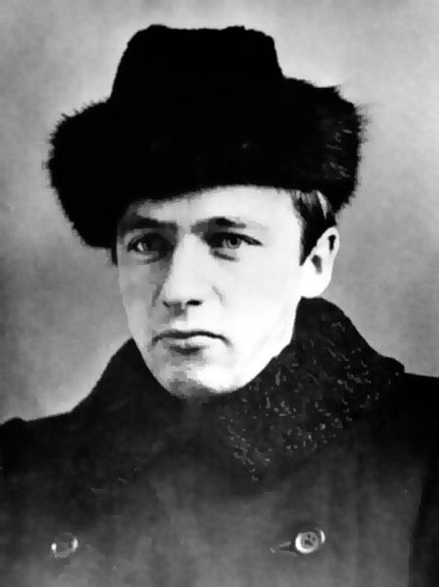

**Timeline of Life and Major Works**

1885: Born as Viktor Vladimirovich Khlebnikov in the small Buddhist village of *Malye Derbety* (*Баһ Дөрвд*) into the family of an ornithologist in what constitutes the present-day Kalmykia and what was Astrakhan *gubernia* at the time of Khlebnikov’s birth. Khlebnikov’s grand-grandfather Ivan was a wealthy merchant (*kupetz pervoi gil’dii*) and an honorary citizen of Astrakhan’.

1891-1895: Khlebnikov’s father frequently changes places of employment; Khlebnikov enrolls into a gymnasium in Simbirsk (famous later as Vladimir Lenin’s home-town). The family then moves to the city of Kazan.

1903: Graduates from a Kazan gymnasium and enters the Kazan State university (also famous due to Lenin having studied there) where he reads mathematics and physics.

1904: Participates in an anti-government movement. Changes his faculty of studies to the Natural Sciences.

1904: It is the year of Khlebnikov’s first literary exercises. Composes a text of a theater play titled “Elena Gordiachkina” and sends it to Maxim Gorky’s journal (without any success).

1904-1907: Takes part in ornithological expeditions set in the Urals and Dagestan. Publishes several ornithological scholarly papers.

1906: Accepted as a member of the Kazan Society for Natural Sciences; his paper focusing on a particular variety of a cuckoo-bird is praised.

1908: Khlebnikov creates his own original poetry, sending some of his pieces to the renowned Symbolist author Viacheslav Ivanov.

1908: By September, changes his academic affiliation to the University of St. Petersburg. Relocates there and continues writing new poetry.

1908-1909: Khlebnikov moves in the Symbolists circles. He is especially close to Alexei Remizov. Khlebnikov explores Slavic mythology as a major source of inspiration for his works.

1909: Lives in Kiev and St. Petersburg. Takes part in the poetic happenings at the “Tower” of Viacheslav Ivanov.

1909: Transfers his official papers to the philological faculty of the University of St. Petersburg. Meets Mikhail Kuzmin, a major Russian poet.

1909: Autumn – assumes the formal pseudonym of *Velimir*, etymologically linked with the Southern Slav form meaning the *Big World*.

1909: Khlebnikov is associated with the *Apollon* journal which stands for a connoisseur-circle of new Russian poetry.

1910: Vasily Kamensky acquaints Khlebnikov with the New Russian art symbolized by Mikhail Matiushin. His other new acquaintances include Elena Guro and the Brothers Burliuk.

1910: Khlebnikov’s groundbreaking poem “Incantation by Laughter” is published in the “Impressionist Studio” collection. April 1910: the Futurist collection “Sadok Sudei” (A Trap for Judges) is published, incorporating several texts by Khlebnikov.

1910: Joins Russian Futurists at the Chernianka estate in the Southern Ukraine where David Burliuk had a household. These whereabouts will give a new name to the group of the Russian Futurists: Hylea.

1911: Expelled from the University of St Petersburg for not having settled his tuition fees.

1911: Travels to Astrakhan’ by a river route.

1912: Khlebnikov’s first separate publication, the dialog “Uchitel i uchenik” (*A teacher and* [his] *disciple*) appears in print. Khlebnikov offers his unique concept of time and history, predicting the revolutionary events of the year 1917.

1912: The major Futurist poem “A Game in Hell” (*Igra v adu*) co-authored with Alexey Kruchenykh appears in print.

1912: Khlebnikov co-authors the Futurist manifesto brochure “A Slap In the Face of Public Taste”. Many of his new poems are published in the same collection.

1913: Publishes some of his texts in the newspaper “Slavianin” (*The Slav*). Rejoins his parents in Astrakhan’.

1913: The first Futurist opera “Victory over the Sun” is staged. Khlebnikov authored the prologue.

1914: F.T. Marinetti visits Russia. Khlebnikov composes an anti-Marinetti leaflet to be distributed at all the venues of his lectures.

1914: Two collections of Khlebnikov’s poems are published by Burliuk and Matiushin.

1914: The First World War begins. Khlebnikov intends to discover the laws of time responsible for such major cataclysms.

1915: Khlebnikov passes his time in various locales in Moscow and St Peterburg.

1914-1915: Befriends Pavel Filonov, the great Russian Avant-Garde painter.

1916: Khlebnikov’s friends proclaimed him the *King of Time* (*Korol’ Vremeni*).

1916: Khlebnikov is enlisted in the infantry, sends a letter to a psychiatrist, Nikolay Kul’bin, asking for his assistance to avoid the military service.

1917: Released from military duty based on ill health.

1918: In Astrakhan, contributes to the newspaper “Krasnyi Voin” (*The Red Warrior*).

1919: Lives in Kharkiv, Ukraine. Gets medical treatment at the psychiatric hospital “Saburova Dacha” in order to avoid enlistment into the White Guard service. Composes the poem “Ladomir”.

1920: Sergei Esenin and Anatoly Mariengof in a public ceremony playfully proclaim Khlebnikov the “Chairman of the Globe” (*Predsedatel’ Zemnogo Shara*).

1920: Travels to Baku, Azerbadzjan.

1921: Within the ranks of the Russian Revolutionary Army Khlebnikov proceeds to Iran where he takes part in establishing the New Socialist Republic of Iran. Creates his major longer poem *Truba Gul’-Mully* (*Gull Mulla’s trumpet*), also known as “*Tiran bez te*”(*A tyrant without a T*).

1922: Resides in the Stavropol region. Travels briefly to Moscow. Khlebnikov’s major works *Zangezi* and *Doski Sud’by* (*Boards of Fate*) are written though not published as he hoped.

1922: Suffers from fever outbursts and ill health in general. A friend, Petr Miturich (the future husband of Velimir’s sister Vera), offers him a haven at the Santalovo village near Novgorod. Khlebnikov succumbs to a paralysis and suffers from severe malnutrition. The poet subsequently dies from a deadly combination of illnesses.

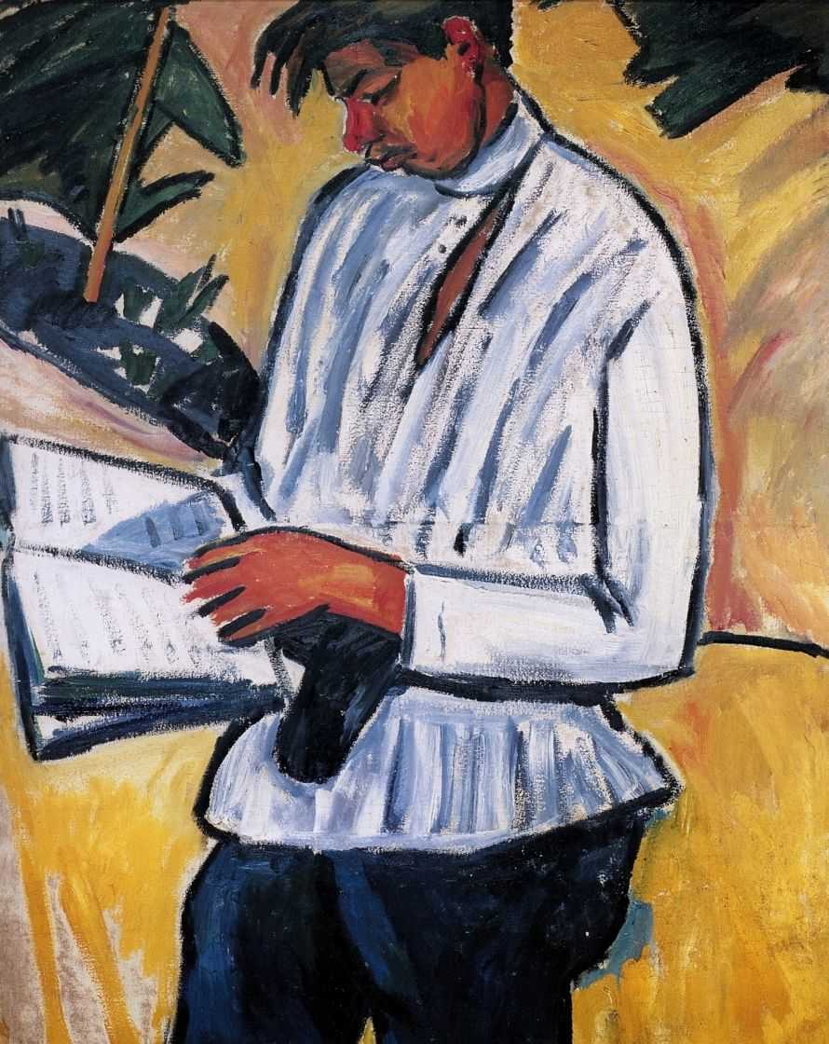

A major poet of Russian Futurism, Velimir Khlebnikov was born and grew up in provincial Russia. Khlebnikov studied mathematics and physics, transferred to the natural sciences and published a number of papers on ornithology. Following a move to St. Petersburg, Khlebnikov became immersed in the capital’s literary milieu, making friends with some of the dons of Russian Symbolism, most notably Vyacheslav IVANOV who admired his work. Subsequently Khlebnikov became acquainted with David BURLIUK and Vladimir MAYAKOVSKY and became deeply involved in the Futurist movement that led to his deepest involvement in the Futurist project of Russian Modernism. The ground-breaking collection published under the name of “A Slap In the Face of Public Taste” (1912) featured many texts by Khlebnikov. He actively participated in all the major activities of the group (which acquired the Slavic name of “Budetliane” as a native parallel to Futurism), collaborated with the poet and musician Mikhail Matiushin, and worked on the first Futurist opera “Victory over the Sun”. Khlebnikov’s experiments with poetic language are considered to be among the most radical and far-reaching in modernist literature. The poet virtually invented a language of his own (at times called “zvezdnyj iazyk”, *the language of stars*).

Khlebnikov was mobilized for service in World War One, but was released thanks to documents provided by fellow artist and psychiatrist Nikolay Kul’bin. Along with fellow Futurists Mayakovsky, Burliuk and Kruchenykh, Khlebnikov sincerely welcomed the October Revolution and dedicated several poems to its victory. After the Revolution Khlebnikov lived in the Russian South, including Ukraine and Astrakhan’, having a vagabond life. The interplay between Khlebnikov’s lifestyle and his artistic creativity became part of the modernist phenomenon of “life-creation.”

Portrait of Khlebnikov by Mikhail

Larionov, 1910.

Khlebnikov’s wanderings directed him to Kharkiv, Baku, Astrakhan and further to Azerbaijan and Iran. Upon his arrival in the Iranian province of Gilan, Khlebnikov began to write his major poem “Tyrant Without the ‘T’”, initially titled “The Trumpet of the Gul’ Mullah”. Practically every researcher of “Tyrant Without the ‘T’” would see this text as a concrete, biographical (and at the same time poetic, allegorical) diary of Khlebnikov’s period in Gilan. As one biographer noted, “the stay in Persia with all its challenges of the road and wanderings was one of the brightest and happiest periods in the poet’s life”. During Khlebnikov’s Baku and Gilan periods, the indigent “wandering”, so important in the dervish culture, was manifested by the total disregard to the matters of outfit and outward appearance, comfort and money. In “Tyrant Without the ‘T’”, the poet crafted his personal life myth, the myth of a poet-prophet and god-seeking dervish. Literature and “literary experience” were merged into one.

Exhausted by the calamities of the post-revolutionary period, Khlebnikov eventually found himself ill and homeless. His friend, the painter Piotr Miturich, offered him shelter in his home in the small village of Santalovo in the Novgorod region. There Khlebnikov died suffering from malnutrition and a combination of several diseases.

“Incantation of Laughter”

We laugh with our laughter

loke laffer un loafer

sloaf lafker int leffer

lopp lapter und loofer

loopse lapper ung lasler

pleap loper ech lipler

bloop uffer unk oddurk

floop flaffer ep flubber

fult lickles eng tlickers

ac laushing ag lauffing uk

luffing ip luppling uc

lippling ga sprickling

urp laughter oop laughing

oop laughing urp laughter.

Translated from Russian by Charles Bernstein.

**Further reading**:

For the English studies on Khlebnikov see:

Cooke, Raymond, *Velimir Khlebnikov: A Critical Study*, Cambridge University Press, 1987.

A comprehensive English biography of the poet along with a thorough analysis of his major works.

Markov, Vladimir, *The Longer Poems of Velimir Khlebnikov*, Berkeley, University of California Press, 1962.

A pioneering study of the poet’s longer texts with comprehensive analysis of its poetics and imagery.

Vroon, Ronald, *Velimir Khlebnikov’s Shorter Poems: a key to the coinages*, Ann Arbor : Dept. of Slavic Languages and Literatures, University of Michigan, 1983.

An in-depth analysis of Khlebnikov’s poetic language.

Weststeijn, Willem, *Velimir Chlebnikov and the Development of Poetical Language in Russian Symbolism and Futurism*, Amsterdam, Rodopi, 1983.

Provides a detailed account of Khlebnikov’s poetics analyzed in comparison with the preceding literary tradition of Russian Symbolism.

Translation of Khlebnikov’s works is available at:

*Collected works of Velimir Khlebnikov*, translated by Paul Schmidt, edited by Charlotte Douglas. Cambridge, Mass., Harvard University Press, 1987-1997.

**Dennis Ioffe, Ghent University**.